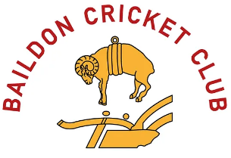
Application form
Thank you for supporting Baildon Cricket Club via the 100 club. Your help really is important in the running of the club.
Please complete the below form and email it back ASAP to baildoncc100club@gmail.com and a number will be allocated.
Name
Address
Post code
Telephone Number
Email Address
Numbers required

Please set up a Direct Debit or standing order for the 15th of the month for £5 per month or £60 per year, to the details below. Please inform once this is active.
Baildon Cricket Club
Sort Code 201181
Account Number 10069701

Draws will take place the last Friday of the month, winners will be notified and prize money sent with in 5 days of contact.
Please sign to agree to the rules and regulations below and to be part of the 100 club.
Signed Date

Number/s allocated______________________
(For office use only)
Rules and regulations.
- By completing the above form, you are committing to a monthly payment of £5 per number to the 100-club draw.
- £5 per month buys you one number (that we will allocate) in the monthly draw. £10 per once will buy two and so on.
- All participants must be over 18 years of age.
- The Draw will take place on the last Friday of the month.
- Winners will be notified and payment will be made by bank transfer within 5 days of contact.
- Winners will be posted on the Baildon Cricket club website and social media platforms. If you don’t want your name published please inform the club via baildoncc100club@gmail.com
- At least 50% of the membership will be awarded in prizes, the remainder will go to the club.
- At least one months’ notice must be given via email to end your membership;
- Any queries please contact Gill Holmes via baildoncc100club@gmail.com

Thank you for supporting Baildon Cricket Club, without continued help form players and supporters the club wouldn’t continue.

